Yueyang sun   
password assignment  
screenshots

default

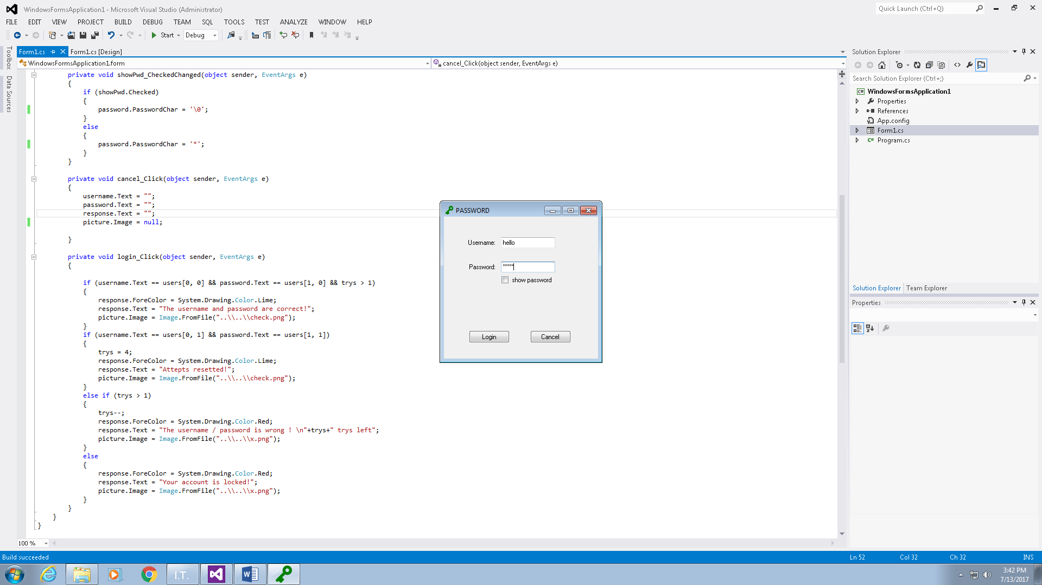

Show pwd

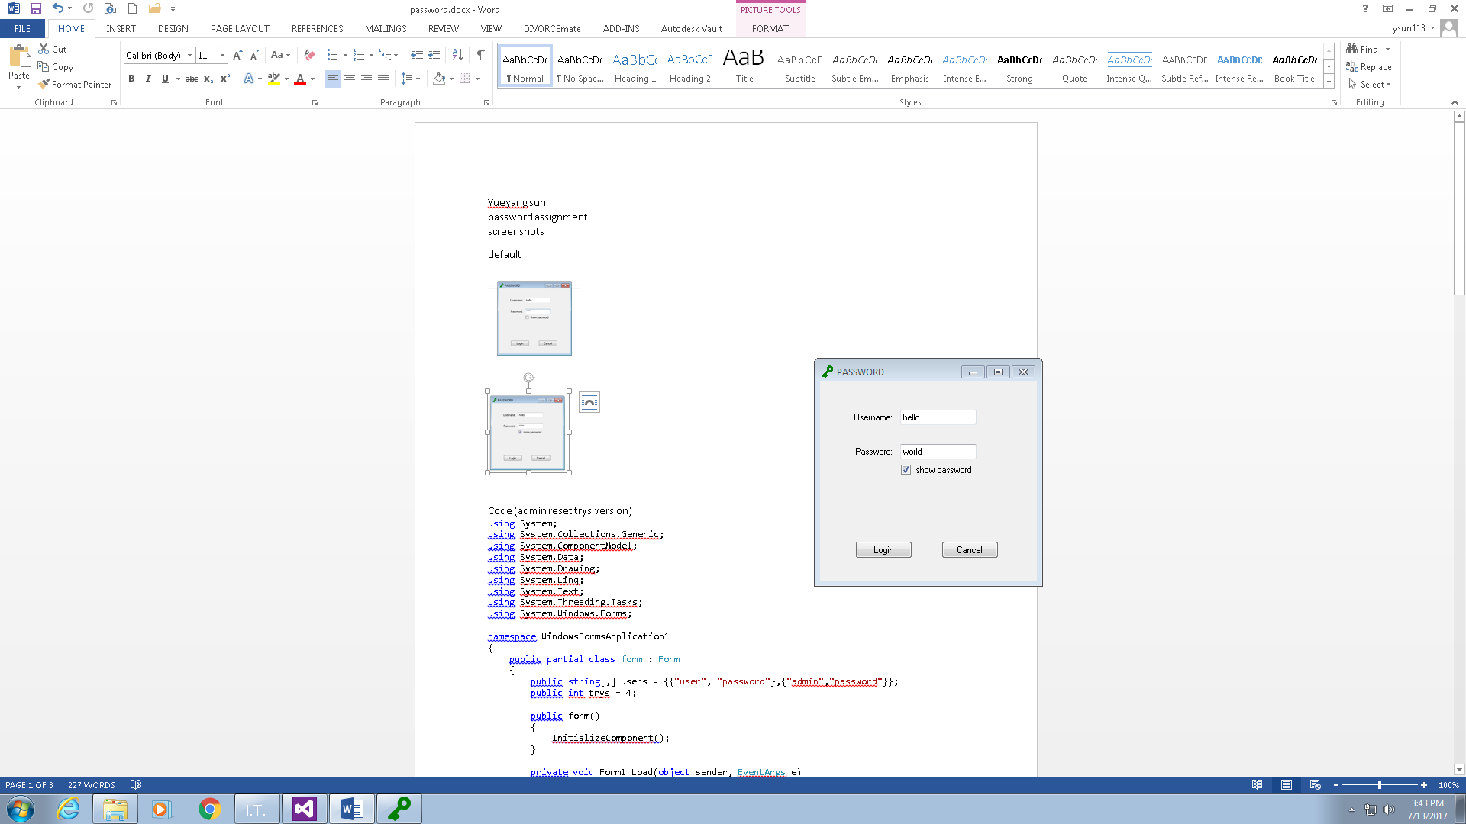

Wrong user/pwd

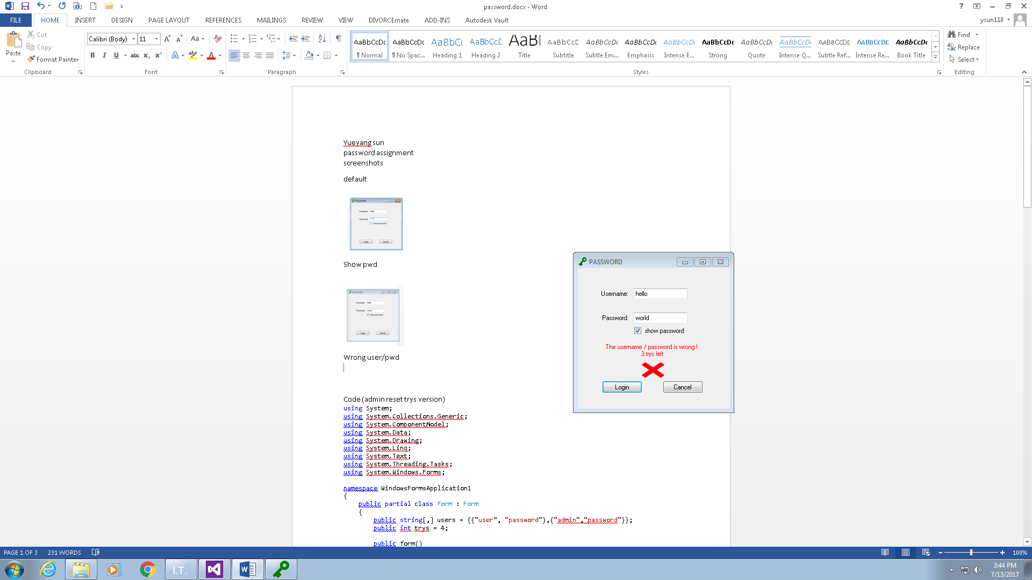  
fail 3 attempts

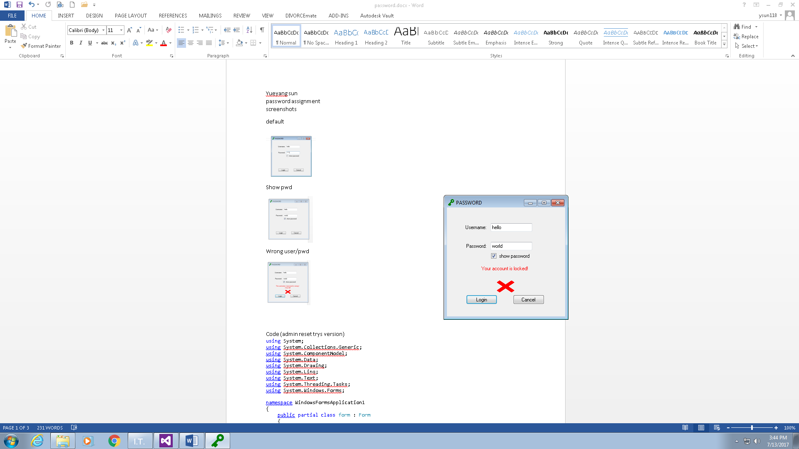

Log in with admin account

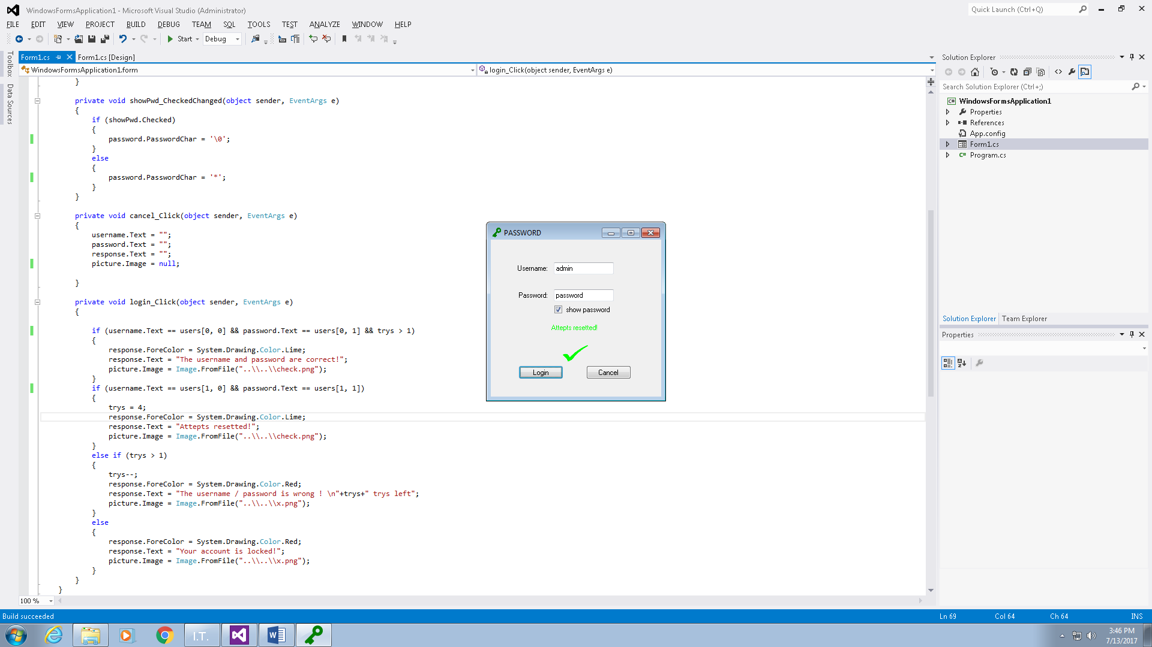

Login with regular account

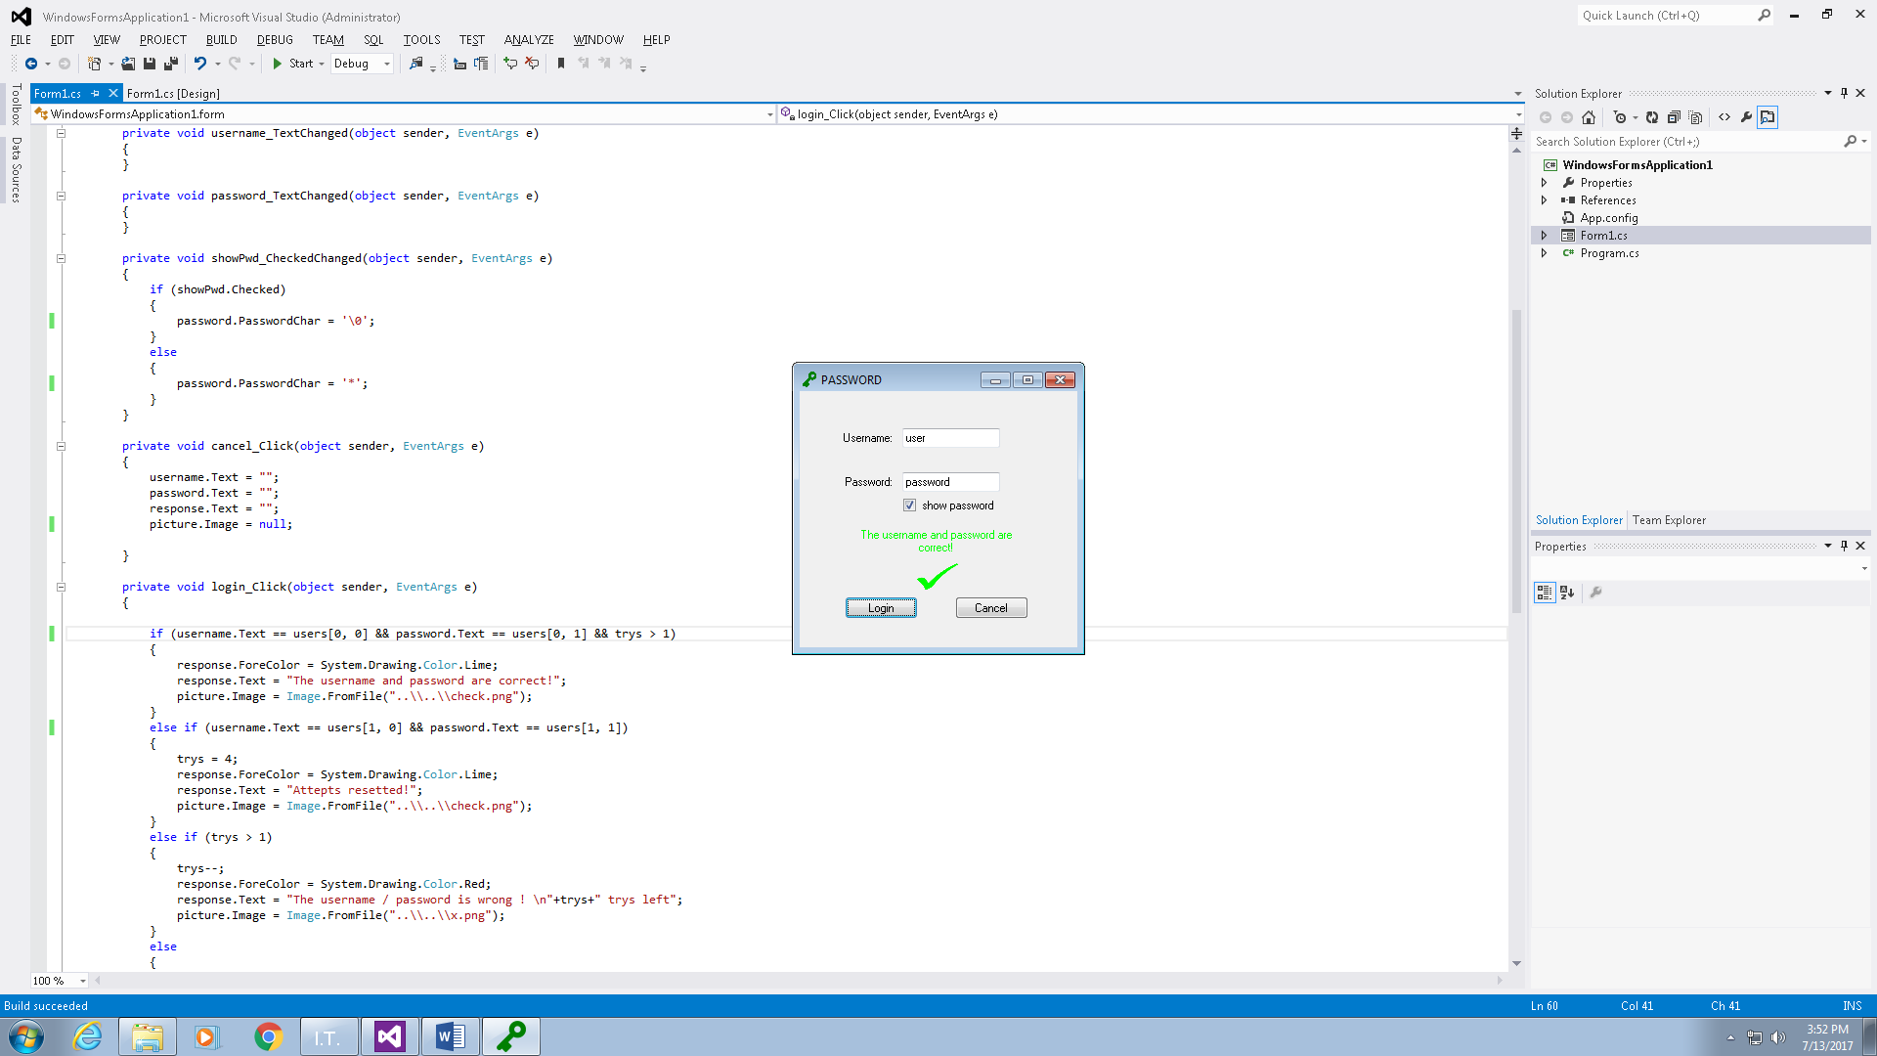  
cancel button

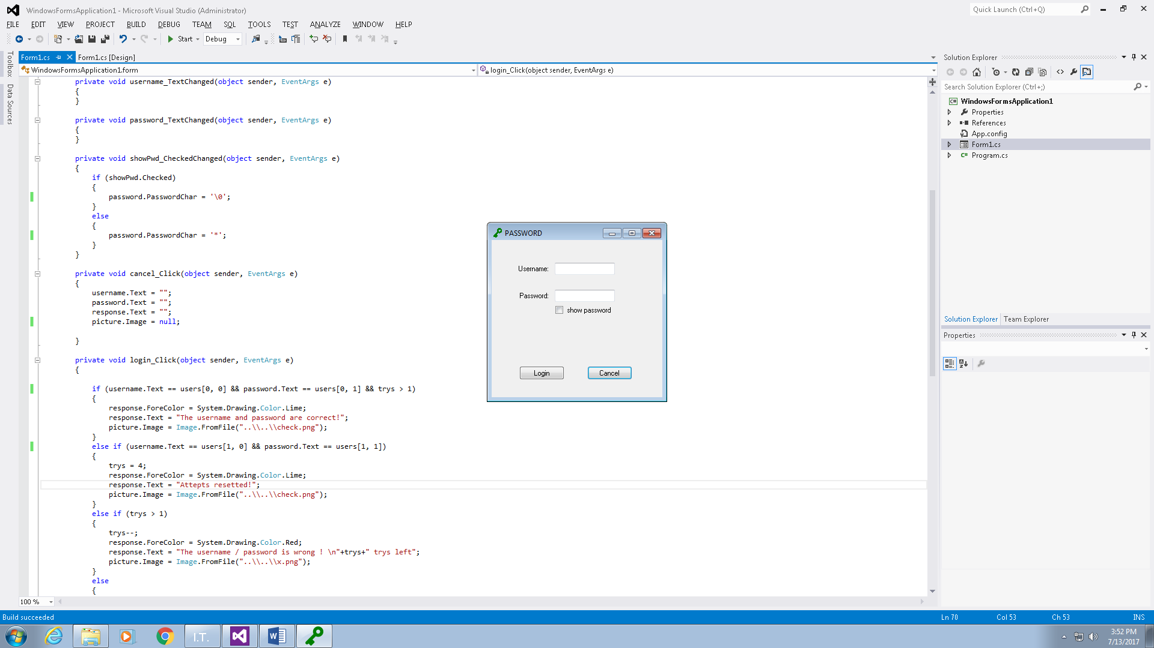

Fail all attempts (no admit reset version, input box gets disabled)

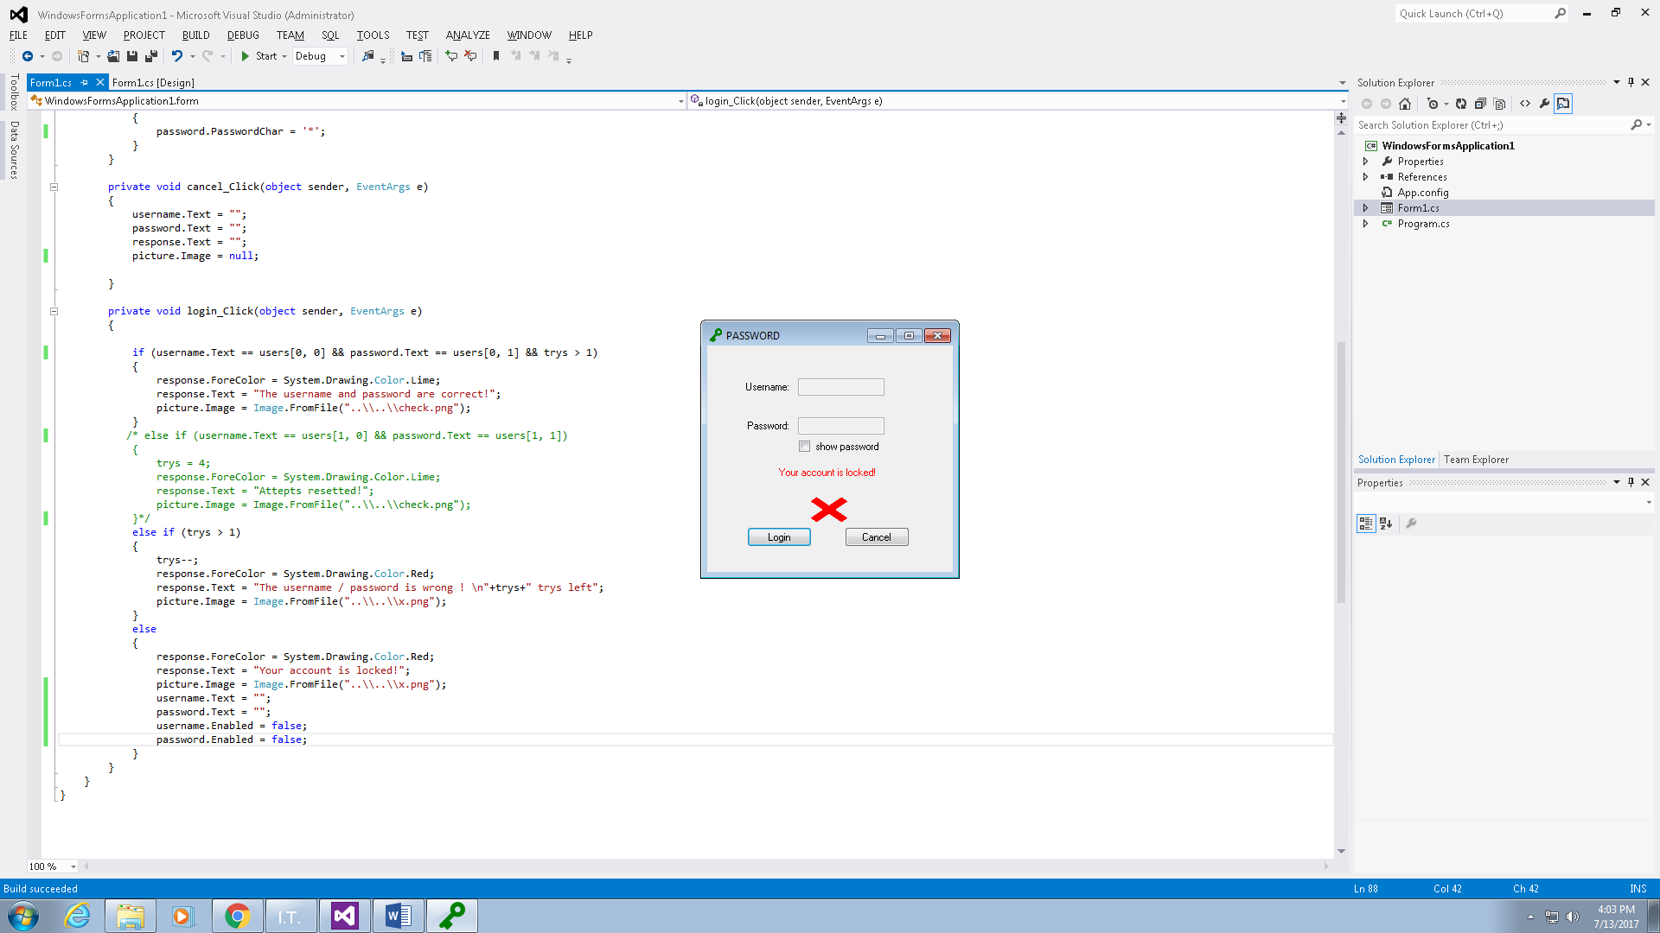

Code and description (admin reset trys version)  
using System;

using System.Collections.Generic;

using System.ComponentModel;

using System.Data;

using System.Drawing;

using System.Linq;

using System.Text;

using System.Threading.Tasks;

using System.Windows.Forms;

namespace WindowsFormsApplication1

{

public partial class form : Form

{

public string[,] users = {{"user", "password"},{"admin","password"}};

**// defining the users and password**

public int trys = 4;

**// start from 4 anything below 2 will fail to trigger login condition**

public form()

{

InitializeComponent();

}

private void Form1_Load(object sender, EventArgs e)

{

}

private void username_TextChanged(object sender, EventArgs e)

{

}

private void password_TextChanged(object sender, EventArgs e)

{

}

private void showPwd_CheckedChanged(object sender, EventArgs e)

{

**//change the characters shown in the password box base on if this check box is checked**

if (showPwd.Checked)

{

password.PasswordChar = '\0';

}

else

{

password.PasswordChar = '*';

}

}

private void cancel_Click(object sender, EventArgs e)

{

**//cancel button resets all the texts and image**

username.Text = "";

password.Text = "";

response.Text = "";

picture.Image = null;

}

private void login_Click(object sender, EventArgs e)

{

if (username.Text == users[0, 0] && password.Text == users[0, 1] && trys > 1)

{

**// show these if they entered the right user info and trys is within 4-2**

response.ForeColor = System.Drawing.Color.Lime;

response.Text = "The username and password are correct!";

picture.Image = Image.FromFile("..\\..\\check.png");

}

else if (username.Text == users[1, 0] && password.Text == users[1, 1])

{

**// show these if they entered admin user info**

trys = 4;

response.ForeColor = System.Drawing.Color.Lime;

response.Text = "Attepts resetted!";

picture.Image = Image.FromFile("..\\..\\check.png");

}

else if (trys > 1)

{

**//trys not used up, doesn’t match any user account info, show trys left**

trys--;

response.ForeColor = System.Drawing.Color.Red;

response.Text = "The username / password is wrong ! \n"+trys+" trys left";

picture.Image = Image.FromFile("..\\..\\x.png");

}

else

{

**//show these if trys used up and not admin account info**

response.ForeColor = System.Drawing.Color.Red;

response.Text = "Your account is locked!";

picture.Image = Image.FromFile("..\\..\\x.png");

}

}

}

}

Code and description(disable entry when trys used up version)  
using System;

using System.Collections.Generic;

using System.ComponentModel;

using System.Data;

using System.Drawing;

using System.Linq;

using System.Text;

using System.Threading.Tasks;

using System.Windows.Forms;

namespace WindowsFormsApplication1

{

public partial class form : Form

{

public string[,] users = { { "user", "password" }, /*{ "admin", "password" }*/ };

**//admin info commented out since there’s no point of an having an admin on this version if the input boxes will be disabled and even admins can’t login**

public int trys = 4;

public form()

{

InitializeComponent();

}

private void Form1_Load(object sender, EventArgs e)

{

}

private void username_TextChanged(object sender, EventArgs e)

{

}

private void password_TextChanged(object sender, EventArgs e)

{

}

private void showPwd_CheckedChanged(object sender, EventArgs e)

{

if (showPwd.Checked)

{

password.PasswordChar = '\0';

}

else

{

password.PasswordChar = '*';

}

}

private void cancel_Click(object sender, EventArgs e)

{

username.Text = "";

password.Text = "";

response.Text = "";

picture.Image = null;

}

private void login_Click(object sender, EventArgs e)

{

if (username.Text == users[0, 0] && password.Text == users[0, 1] && trys > 1)

{

response.ForeColor = System.Drawing.Color.Lime;

response.Text = "The username and password are correct!";

picture.Image = Image.FromFile("..\\..\\check.png");

}

/* else if (username.Text == users[1, 0] && password.Text == users[1, 1])

{

trys = 4;

response.ForeColor = System.Drawing.Color.Lime;

response.Text = "Attepts resetted!";

picture.Image = Image.FromFile("..\\..\\check.png");

}*/

**//again, login boxes gets disabled, so no point of having an admin**

else if (trys > 1)

{

trys--;

response.ForeColor = System.Drawing.Color.Red;

response.Text = "The username / password is wrong ! \n"+trys+" trys left";

picture.Image = Image.FromFile("..\\..\\x.png");

}

else

{

**//reset text boxes then disable the boxes**

response.ForeColor = System.Drawing.Color.Red;

response.Text = "Your account is locked!";

picture.Image = Image.FromFile("..\\..\\x.png");

username.Text = "";

password.Text = "";

username.Enabled = false;

password.Enabled = false;

}

}

}

}